# Benchmark GTX 680 DC2T – 2GD5 vs. GTX 970 Gaming 4G.

Unigine Valley Benchmark 1.0 – DirectX 11 – Ultra – 1920x1080 fullscreen

Intel Core i7 3770k @ 3.5GHz – 2x 8Go RAM DDR3 1600MHz   
SSD OCZ Vertex 4 – 256 Gb  
Windows 8.1 Pro x64 – ForceWare 344.11

GTX 680 DC2T – Temp max : 70°c  
GTX 970 – Temp max : 67°c (-4%)

* **Anti-Aliasing 4X :**

FPS: 59.6   
Score: 2493   
Min FPS: 26.8   
Max FPS: 120.9

FPS: 71.9 *(+20%)*  
Score: 3009   
Min FPS: 30.4 *(+13%)*   
Max FPS: 141.6 *(+17%)*

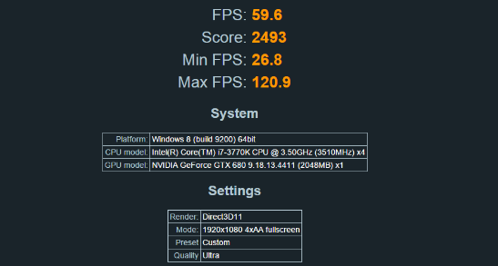 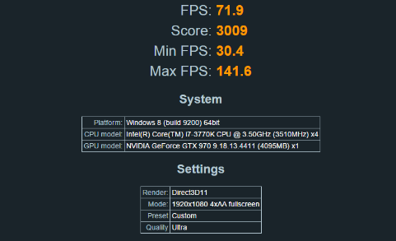

* **Anti-Aliasing 8X :**

FPS: 45.2   
Score: 1890   
Min FPS: 17.7   
Max FPS: 84.8

FPS: 58.0 *(+28%)*  
Score: 2427   
Min FPS: 20.1 *(+13%)*  
Max FPS: 109.6 *(+29%)*

